**4G680V2.0 Wireless Router&Access Point**

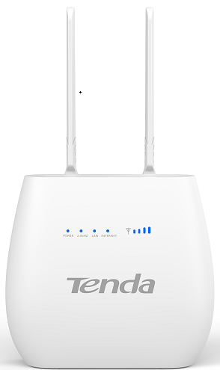

**User Manual**

目录

Chapter 1：Product Overview 4

1.1 Introduction 4

1.1.1 Key Features 4

1.1.2 Product Layout 6

Chapter 2：Quick Setup Guide 9

2.1 System Requirements 9

2.1.1 4G680V2.0 Placement 9

2.2 Network Setup 10

2.2.1 WAN Setting 10

2.2.2 3G/4G Setting 10

Chapter 3：Product Setting 12

3.1 Configuration wizard 12

3.1.1 TCP/IP Setting 12

3.1.2 Log In 13

3.2 Home 13

3.3 Wizard 14

3.4 WAN 14

3.4.1 Connection 14

3.4.2 Wan Setting 15

3.4.3 APN Setting 16

3.4.4 4G/3G/2G Modem 17

3.4.5 PIN 17

3.4.6 PLMN 18

3.5 LAN 18

3.5.1 LAN 18

3.5.2 DHCP 19

3.6 SMS 20

3.7 WiFi 20

3.7.1 Basic 20

3.7.2 WPS 21

3.7.3 MAC Filter 24

3.7.4 Station List 24

3.8 Security 25

3.8.1 Firewall 25

3.8.2 NAT 26

3.8.3 DMZ 26

3.9 System 27

3.9.1 About 27

3.9.2 Voice Setting 27

3.9.3 Qos 28

3.9.4 Configuration 29

3.9.5 Firmware Upgrade 29

3.9.6 Antenna 30

3.9.7 Password 30

3.9.8 Date and Time 31

3.9.9 Language 31

3.9.10 Reboot 32

AppendixⅠ: 33

Appendix II: 34

Appendix III: 36

# Chapter 1：Product Overview

## 1.1 Introduction

Thanks for purchasing 4G680V2.0 broadband router. This router, equipped with the latest 4G and Wireless-N technology, is a full function network equipment. It can support you to freely access network connection in different occasions, such as meeting, exhibition, factory, or home. When using SIM card to access network, you could also make phone calls or send text messages simultaneously. 4G680V2.0 has extraordinary performance, and is very easy to use and manage. It supports multiple devices sharing one broadband link and ISP account, to offer you great convenience and cost efficiency. In the meanwhile, it provides multiple management functions, to configure system, DHCP server, firewall, static route table. 4G680V2.0 broadband router is easy to configure, so non-professionals could configure the device. Before you start to configure 4G680V2.0, please read this user guide, to fully understand the functions of 4G680V2.0.

### Key Features

|  |  |  |  |
| --- | --- | --- | --- |
| **Model** | | **4G680V2.0** | |
| **Dimensions** | | | 125x117x46mm |
| **Communication**  **System (WAN)** | Chipset | | Qualcomm MDM9207 |
| Frequency  Bands | | LTE Band B3/B7/B28  UMTS Band B1/B5/B8  GSM Band B2/B3/B5/B8 |
| Bandwidth | | LTE BAND: 1.4/3/5/10/15/20 MHz, comply with 3GPP |
| Modulation | | Downlink: QPSK/16-QAM/64-QAM, comply with 3GPP  Uplink: QPSK/16-QAM, comply with 3GPP |
| Antenna | | External antenna interface supported |
| RF Power  Level | | LTE FDD: Power Class 3 (23 +/-2dBm)  UMTS: Power Class 3 (24 +1.7/-3.7dBm)  EDGE: Power Class E2 (GSM850/900: 27dBm; DCS/PCS: 26dBm)  GPRS: GSM850/900 Power Class 4: 33dBm;  DCS/PCS Power Class 1: 30dBm) |
| Data Rate | | 4G: 3GPP Cat. 4, Downlink/Uplink up to 150Mbps/50Mbps  3G: 3GPP Downlink/Uplink up to 42Mbps/5.76Mbps  2G: EGPRS Class33 Downlink/Uplink up to 296Kbps/236.8Kbps |
| **External Interface** | LAN/WAN | | 2xRJ45 for 2xLANs |
| RJ11 | | Optional: VoLTE |
| USIM | | Single, 2FF |
| Antenna | | External antenna interface supported, internal/external auto-detecting |
| Power Jack | | 12v1A interface |
| **LED** | Power | | Power Status Indicator |
| Network | | 4G/3G/2G Network Status Indicator |
| Internet | | Internet Connection Status Indicator |
| Wi-Fi | | Wi-Fi Status Indicator |
| LAN | | 2 LEDs for LAN |
| Phone | | RJ11 Status Indicator |
| WPS | | WPS Enable Status Indicator |
| **Button** | Power Key | | Power Switch |
| WPS Key | | Enable WPS |
| Reset Key | | Restore Factory Settings |
| **Memory** | | | 4Gbits + 2Gbits |
| **WebUI** | System | | Connection Status |
| Statistics |
| Device Management |
| Power Mangement |
| Andoid/iOS App Management |
| Mobile Service | | SMS Manager |
| Automatic APN matching according to USIM |
| Auto Data Connection |
| USSD Service |
| PIN/PUK Management |
| Network Mode Selection(2G/3G/LTE/Auto) |
| Router | | 64/128-bit WEP, WPA/WPA2, WPA-PSK/WPA2-PSK encryptions |
| IPv4/v6 |
| VPN Passthrough, VPN Client (Optional) |
| Dynamic IP/Static IP/PPPoE/PPTP(Dual Access)/L2TP(Dual Access) |
| Virtual Server, UPnP, DMZ, DDNS |
| DoS, SPI Firewall, IP Address Filter/Domain Filter |
| IP and MAC Address Binding |  |  |
| Traffic Control (IP QoS) |  |  |
| Access Control, Local Management, Remote Management |  |  |
| **Operation System** | Windows | | XP/7/8/10 |
| MAC OS | | 10.7+ |
| Linux | | Ubuntu 13.04+ |
| Browser | | IE9+, Firefox, Google Chrome, Safari, Opera |
| **WLAN** | Chipset | | RT8192S |
| Frequency | | 2.4GHz |
| Protocol | | 802.11b/g/n |
| Channel | | 1~13 |
| Antenna | | Internal, 2 x 2 |
| Suggested User numbers | | 32 users |
| Data Rate | | 802.11b: Up to 11 Mbps  802.11g: Up to 54 Mbps  802.11n: Up to 300 Mbps |
| **Environments** | Power Supply | | DC adaptor, 12V/1A |
| Working Temperature | | 0°C to 45°C |
| Storage Temperature | | -20°C to 60°C |

### 1.1.2 Product Layout

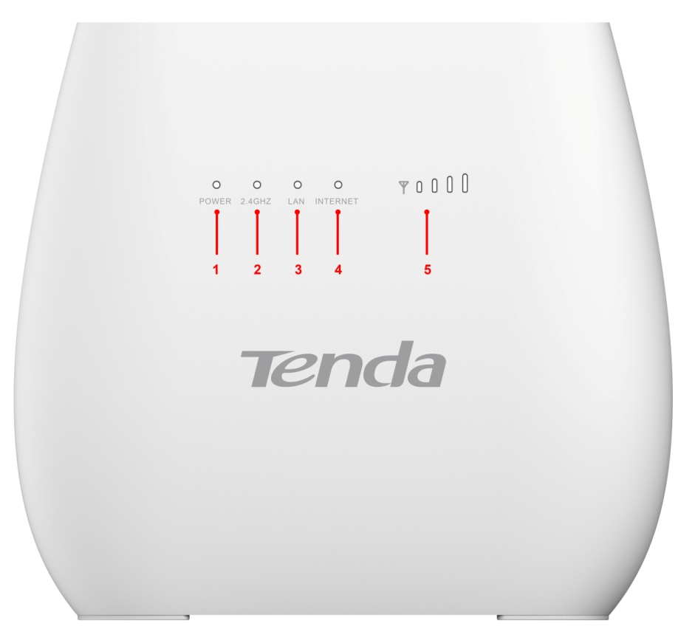

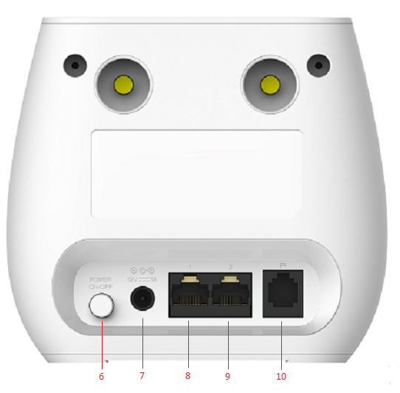

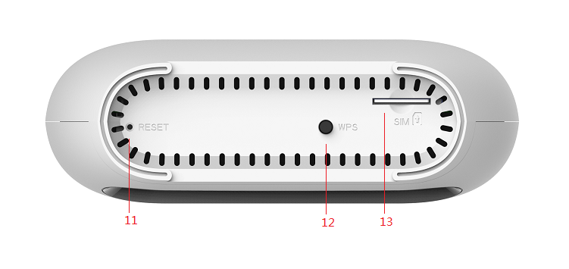

|  |  |  |
| --- | --- | --- |
| Number | LED | Description |
| 1 | Power | A blink green light indicates a proper connection to the power supply |
| 2 | 2.4GHz | Light up in green when WIFI is enabled; blink when data transfer. |
| 3 | WPS | For the WPS connection will shine. |
| 4 | Internet | Light up in green when Internet is enabled. Blink when data transfer. |
| 5 | Signal | Show signal strength. |

|  |  |  |
| --- | --- | --- |
| Number | Connections | Description |
| 6 | Power | Turn on/off the router. |
| 7 | Power Adapter | Connect Power to DC-Jack 12V/1A Power Adapter. Using power supplies with a different voltage from the one included with the 4G680V2.0 will cause damage and void the warranty. |
| 8 | LAN | LAN ports provide connections to Ethernet enabled devices. |
| 9 | WAN/LAN | If the WAN is set to the WAN Mode, will be as the WAN interface, you can dial the DSL module; If WAN set to LAN MODE, will be a LAN interface |
| 10 | TEL | Connect the telephone |

|  |  |  |
| --- | --- | --- |
| Number | Connections | Description |
| 11 | RESET | Press the reset button 3 seconds to restore the device to its factory default settings. |
| 12 | WPS | Click this button to start WPS encryption. |
| 13 | SIM | Insert SIM card to automatically identify registration |

# Chapter 2：Quick Setup Guide

## 2.1 System Requirements

* Ethernet ADSL/Cable with an Ethernet port (RJ-45) **OR** Internet SIM card
* Computer with Windows, Macintosh, or Linux-based operating system with an installed Ethernet adapter.
* Internet Explorer version 8.0 or above, Google Chrome, Safari, Firefox, Opera.

### 2.1.1 4G680V2.0 Placement

You can place 4G680V2.0 on a desk or other flat surface. Please keep 4G680V2.0 away from heating. For optimal performance, please place your 4G680V2.0 in the center of your home (office), in a location that is away from any potential interference source, such as metal walls or microwave oven.

## 2.2 Network Setup

### 2.2.1 WAN Setting

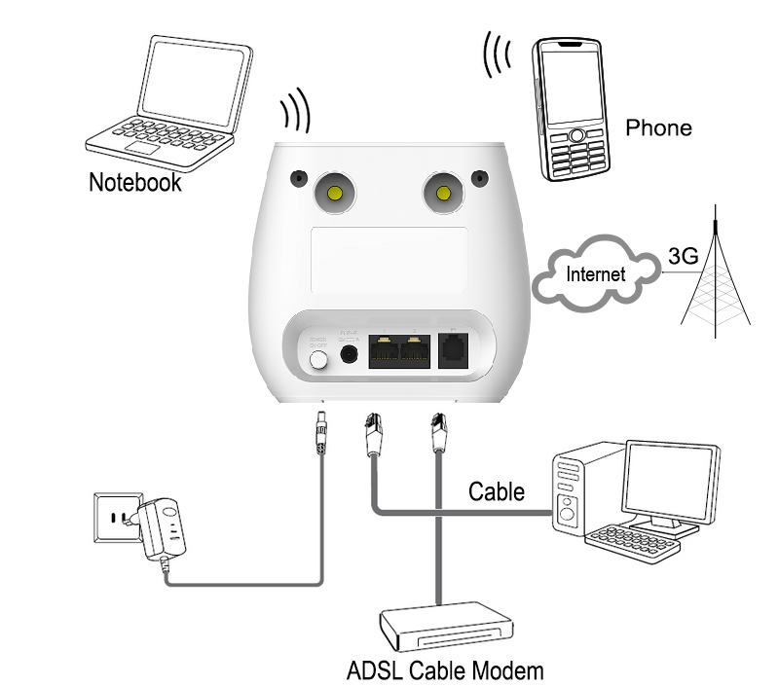

1. Connect Ethernet cable between your PC/Notebook and one of the four available LAN ports on 4G680V2.0.
2. Connect Ethernet cable between WAN ports of your ADSL/CABLE modem and WAN port of 4G680V2.0. Please make sure your ADSL/CABLE modem is working properly. Contact your ISP if you have any question.
3. Power up 4G680V2.0.

### 2.2.2 3G/4G Setting

When using SIM card to access network, you could also make phone calls or send text messages.

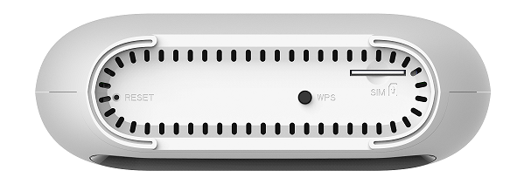

1. Insert SIM card into the port.

(Attention : the SIM card can support the function of plugging during the operation of the equipment.)

1. Power up 4G680V2.0. Press Power button, then front panel will light up and remain stable.

# Chapter 3：Product Setting

## 3.1 Configuration wizard

### 3.1.1 TCP/IP Setting

Enter [Start Menu]—Select [Control panel]—Select [Network]—Select [Local Area Connection]—Select [Properties]

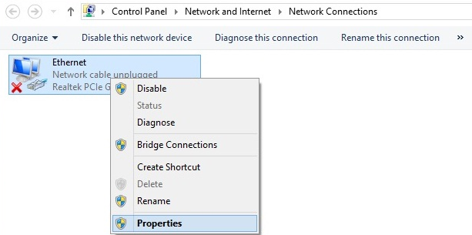

Select [Internet Protocol (TCP/IP)]—Click [Properties]

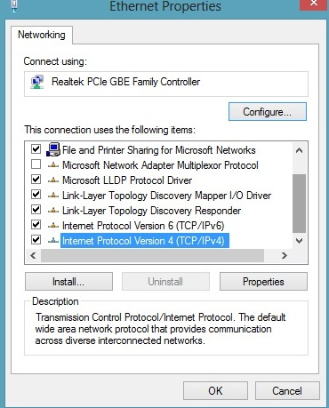

4G680V2.0 supports [DHCP] function, please select both [Obtain an IP address automatically] and [Obtain DNS server address automatically].

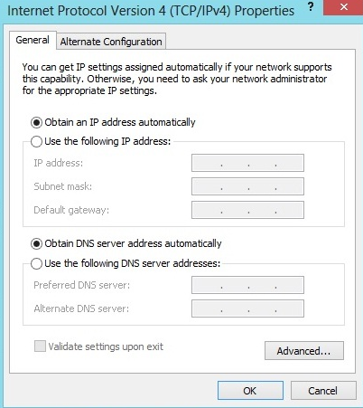

### 3.1.2 Log In

Whenever you want to configure your network or the 4G680V2.0, you can access the Configuration Menu by opening the web-browser and typing in the IP Address of the 4G680V2.0. For example, <http://192.168.0.1> Note: If you changed the default IP Address assigned to the 4G680V2.0, make sure to enter the correct IP Address.



You will go to the overview and log in page. The Factory default user name and password are **admin.** It is recommended to change the admin password for security purpose. Please refer to Administrator Settings to change the admin password.

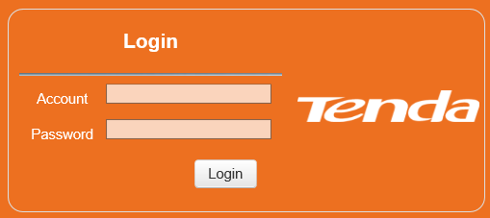

## 3.2 Home

First part of the main display settings and network status information, such as IP address, SIM card status, type and quality of the network signal, whether it is roaming, with or without a new message, and traffic statistics, and system uptime, and so on.

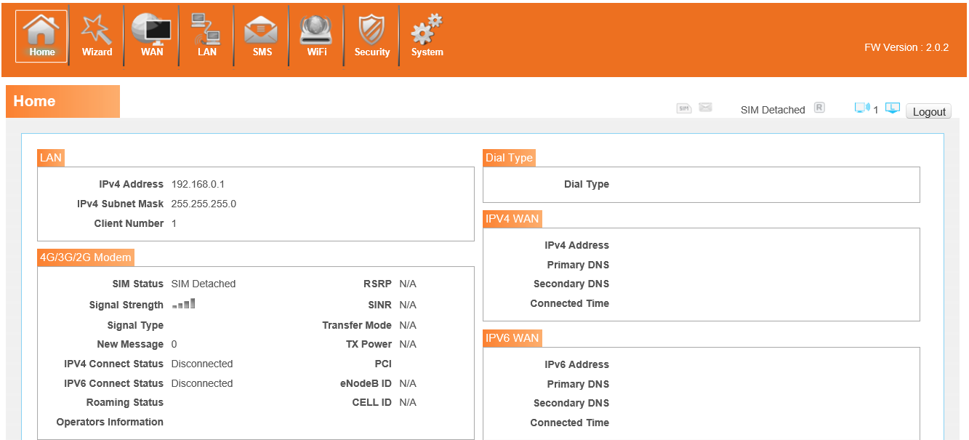

## 3.3 Wizard

## 3.4 WAN

### 3.4.1 Connection

Dialing Mode:

Select the Auto Mode, after you turn on 4G680V2.0 without additional operations, the device will automatically connect to the network; select the Manual Mode, you need to manually connect to the network after opening the 4G680V2.0 management page.

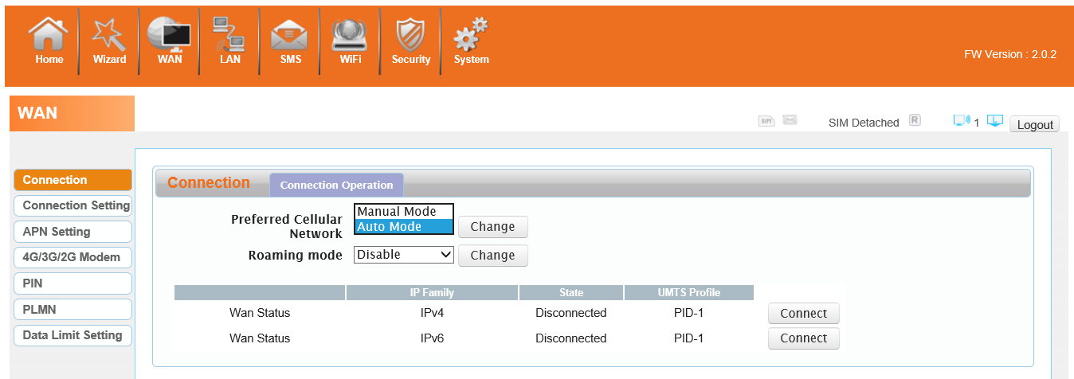

### 3.4.2 Wan Setting

Choose you Internet Access Type.

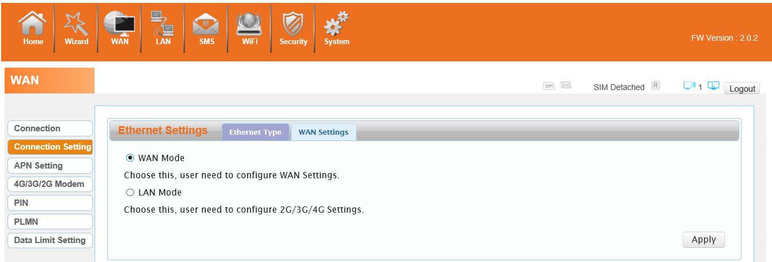

If you choose WAN Mode, please select the type of internet connection for your router.

DHCP：A dynamic IP address connection that configures the router to automatically obtain IP address from a DHCP server on the ISP’s network.

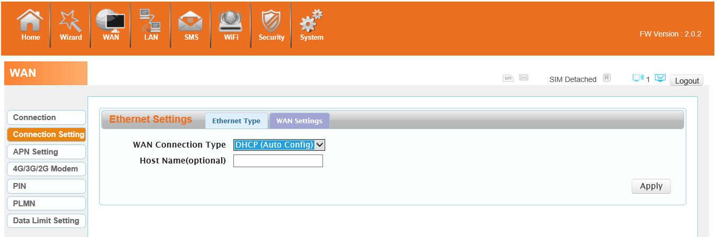

Static Mode: Please enter the IP address information provided to you by your ISP. The Subnet Mask for 4G680V2.0 is preconfigured to 255.255.255.0. Other configurations can be made, but not recommended. This feature is for advanced users. Your ISP should also provide the Default Gateway, Primary DNS and Secondary DNS (optional).

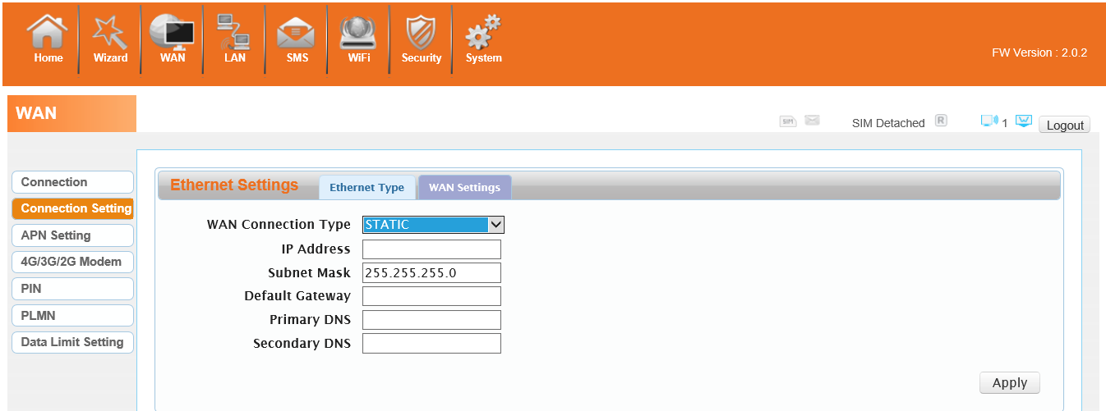

PPPoE: Please enter the PPPoE username and password assigned by your ISP. Choose the Operation Mode; enable the Keep Alive option to automatically re-establish the connection when an application attempts to access the Internet again. The On Demand Mode Idle Time is a maximum period of time for which the Internet connection is maintained during inactivity. If the connection is in activate longer than the Maximum Idle Time, it will be dropped.

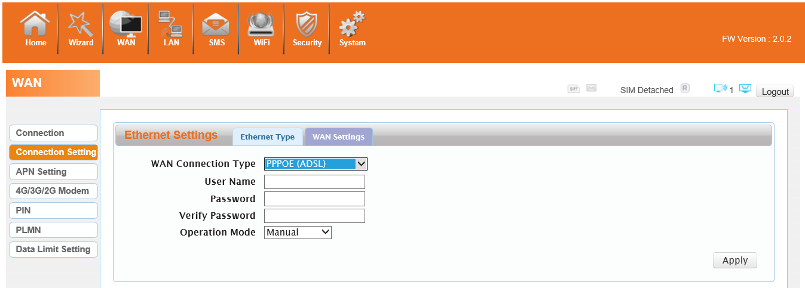

If you choose 3G/4G SIM card to access the network, please enter “APN” and “Dial Number”,”Authentication” and all that at APN setting page, which are provided by your mobile **network** **operator**.

### 3.4.3 APN Setting

You can customize the network configuration or manually add the new APN and set default APN.

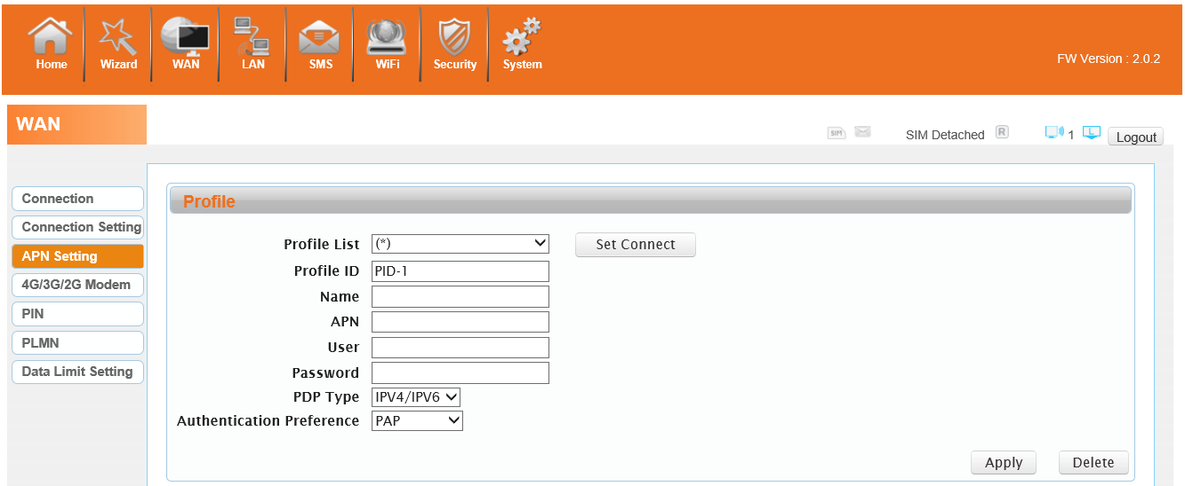

### 3.4.4 4G/3G/2G Modem

There are four types of networks can be choose: Auto is 4G/3G/2G, LTE Only is using only 4G, WCDMA Only is using only 3G,GSM Only is using only 2G.

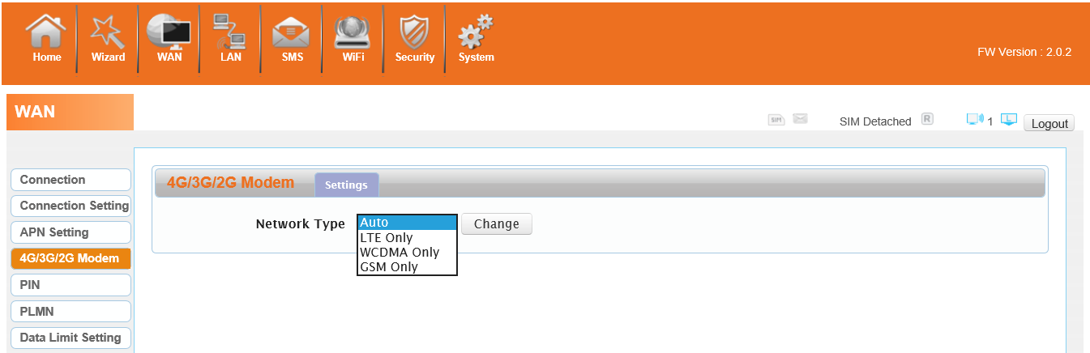

### 3.4.5 PIN

Open your PIN, if you reboot the device, you need to login management page, and the page will prompted to enter the correct PIN code, you can use the SIM card. PIN / PUK code supplied with the SIM card provided by your carrier, please consult your carrier.

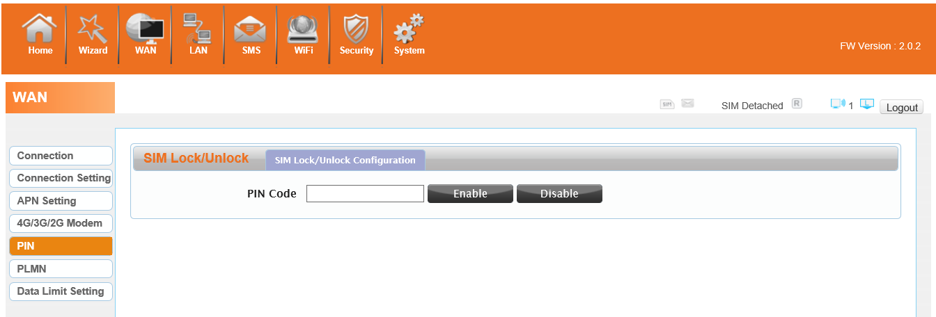

### 3.4.6 PLMN

Automatic： The 4G680V2.0 will automatically select the most appropriate network registration connection.

Manual：click ‘query’ button and choose network which user selected.

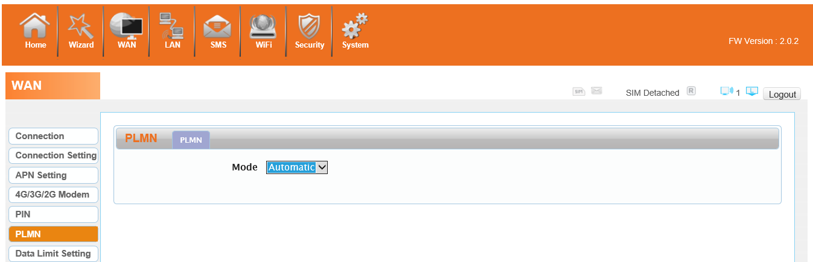

## 3.5 LAN

### 3.5.1 LAN

You can configure the LAN port parameters here.

IP Address: Set LAN IP address of the router.

IP Subnet Mask: Set subnet mask of the router.

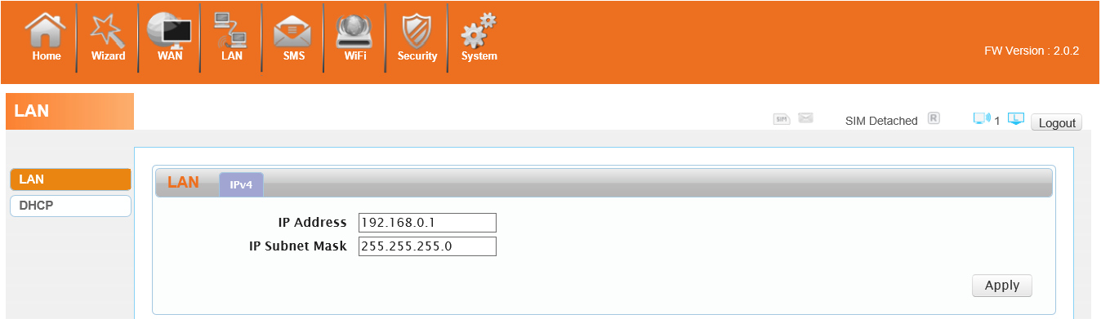

### 3.5.2 DHCP

You can configure the DHCP Settings parameters here.

Starting IP Address & Ending IP Address: The IP range obtained through DHCP by LAN host.

Lease Time: The time limit for the IP address configuration information obtained by the client device at the DHCP server

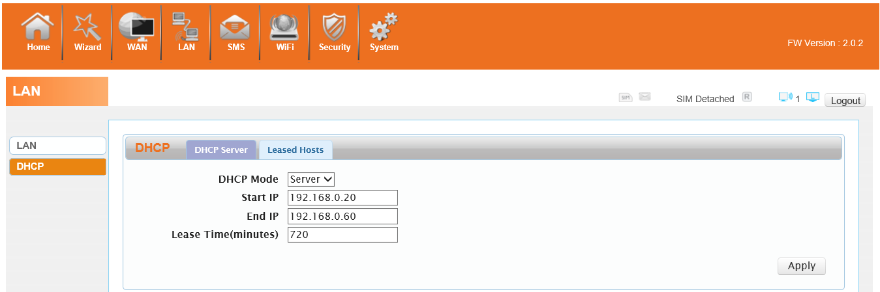

## 3.6 SMS

When using SIM card to access network, you could also send text messages at the time. You can send, receive, reply , forward, and save test messages. You can send 10 text messages at the same time, SMS number intervals with a semicolon. Also you can setting the storage location of messages, and so on. We can operating the SMS in this page.

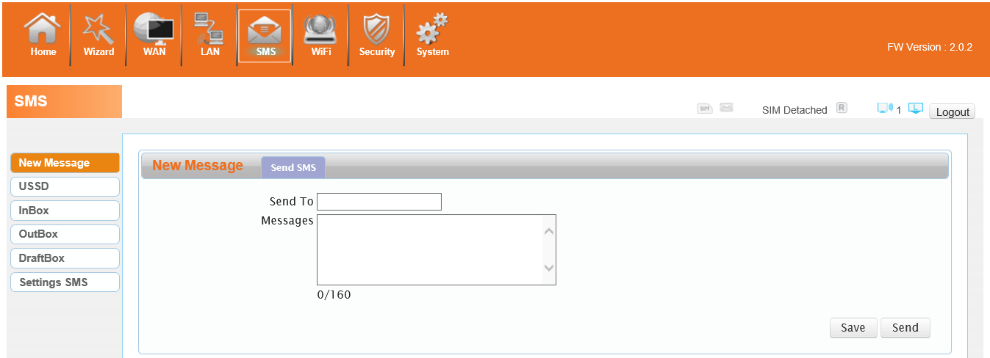

## 3.7 Wi-Fi

### 3.7.1 Basic

It shows some information of the wireless connection.

Enable: Open or close the router wireless function.

Mode: Choose Wireless network protocol such as 11b/g/n and mixed type.

Channel: The channel currently used. You can select channel from 1 to 13. The router will choose the frequency by itself if you select the “Auto”.

SSID: Set the SSID. You can connect the router by this SSID. It can be hidden or isolated. If select Hide function, the router’s SSID cannot be scanned; Select Isolated function, it can prevent wireless communications.

Hide SSID: Enable this function, wireless client will not scan to the router’s SSID.

The router’s security mode supports (Disable， WEP(AUTO)，WPA-PSK，WPA2-PSK，WPAPSKWPA2PSK).

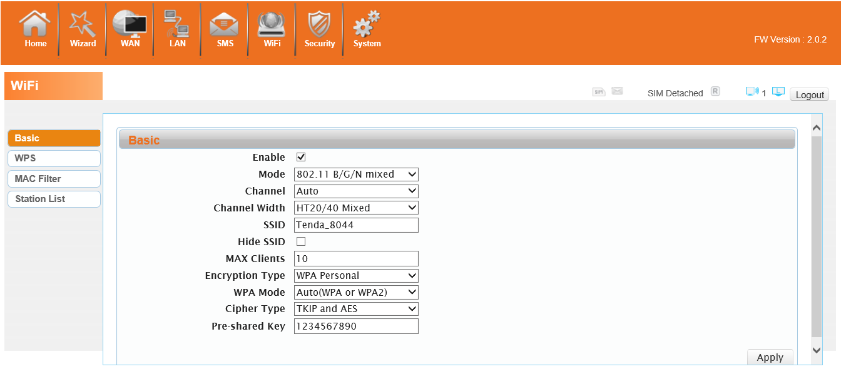

### 3.7.2 WPS

WPS is the simplest way to establish a connection between the wireless clients and the wireless router. You do not have to select the encryption mode and fill in a long encryption passphrase every time when you try to setup a wireless connection. You only need to select enable on WPS configuration and press a button on wireless.

**WPS PBC authentication:**

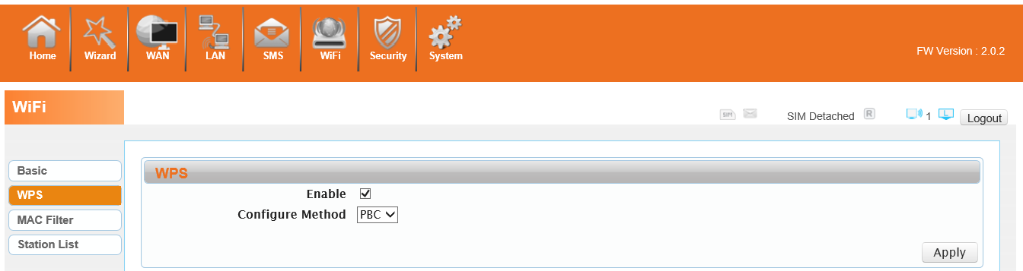

If your WIFI Enabled, Device supports WPS (WIFI Protected Setup) and you have forgotten or do not wish to enter your password to connect to your 4G680V2.0, you may use the following available procedures for quick access to WIFI.

Open the WPS:

WPS can be opened by two methods. The first method is Entering the management interface page, press the ‘Apply ‘, open the WPS. It will continue 120 seconds. Like the following picture.

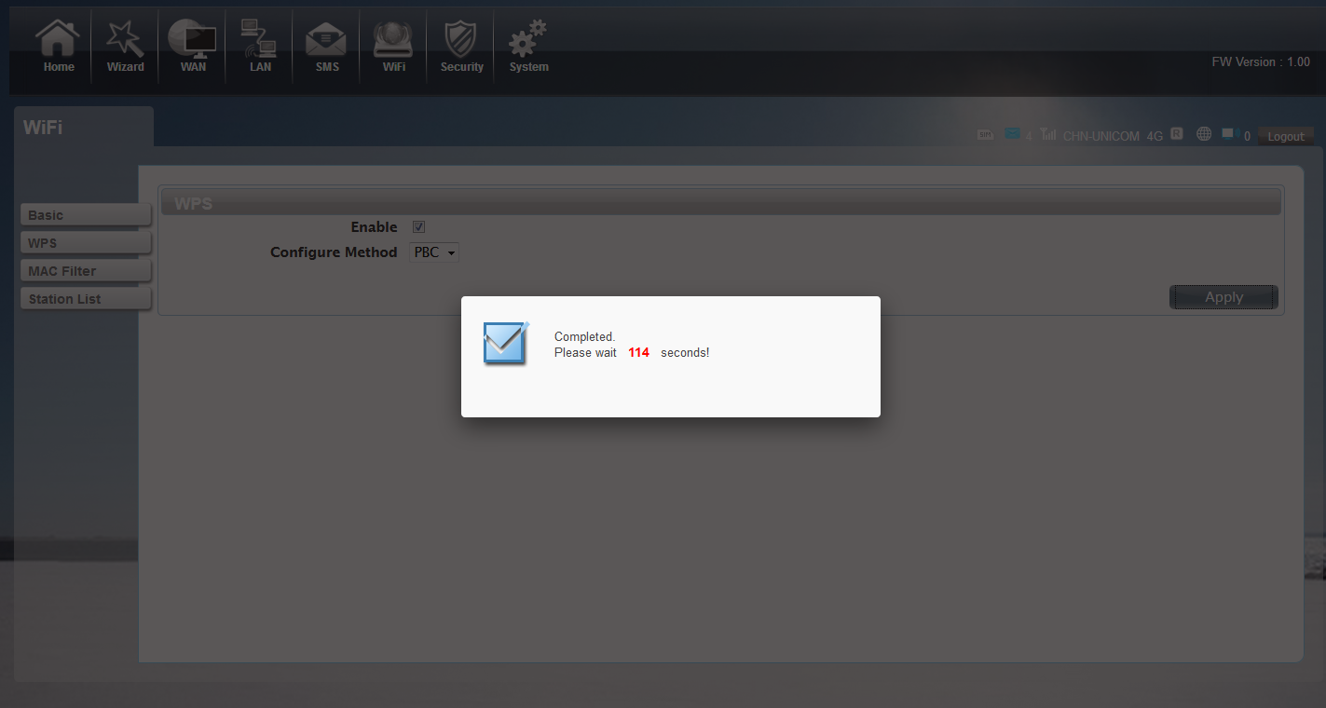

Select the SSID of the device and connect. Then you can see like the following picture.

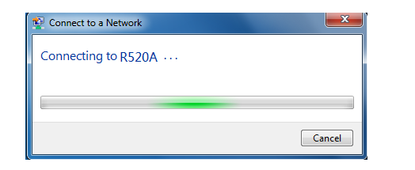

The second method is, Select the SSID of the device and connect

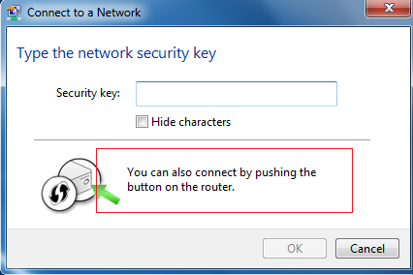

Press the WPS button on the 4G680V2.0, activate the WPS. It will lasting 120 seconds.

Then you can see like the following picture.

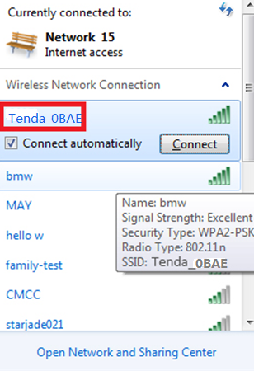

**WPS PIN authentication:**

The connection to the 4G680V2.0 is achieved by inputting the relevant PIN key into the enrollee PIN text box, which you may find in the wireless network card. When you applied. It will lasting 120 seconds. The premise is that the wireless network card or the clients must support WPS PIN authentication. Like the following pictures.

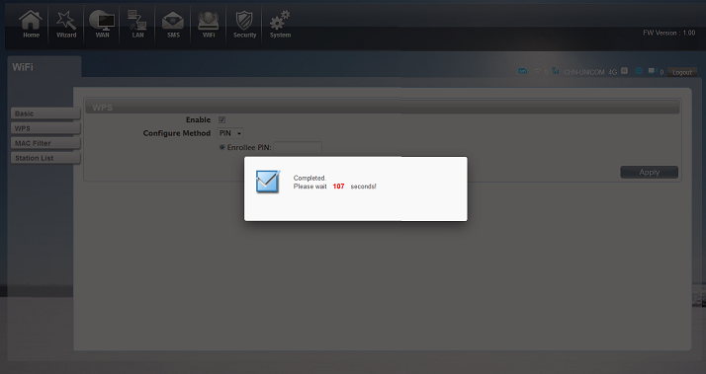

### 3.7.3 MAC Filter

Deny list Stations: If you add the computers or wireless devices MAC address into the list, it can prohibiting the computers or wireless devices connect to the 4G680V2.0.The computes or wireless devices MAC address which are not in the list can able to connect to 4G680V2.0.

Allow list Stations: Opposite with Deny list Stations. It only allows the devices in the list to connect to the 4G680V2.0, other wireless devices are unable to connect to the 4G680V2.0

Disable: It means close the function of the MAC Address Filter.

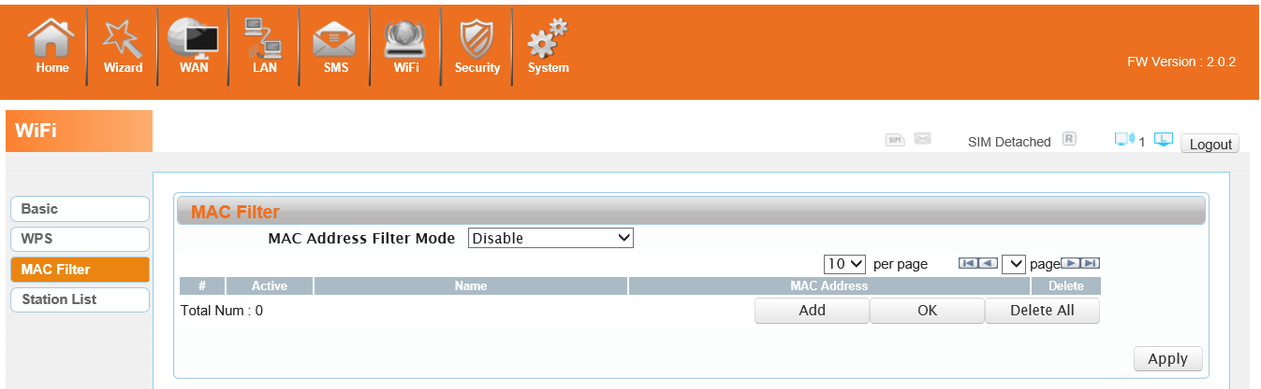

### 3.7.4 Station List

Show the information of wireless devices which are connected to the 4G680V2.0.

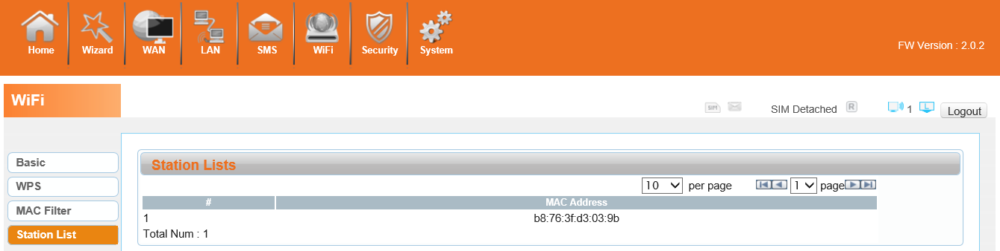

## 3.8 Security

### 3.8.1 Firewall

Firewall configuration: You can Disable or Enable the Firewall function. Also you can set the matching packets rule to receive or reject.

You can add the rule in the list.

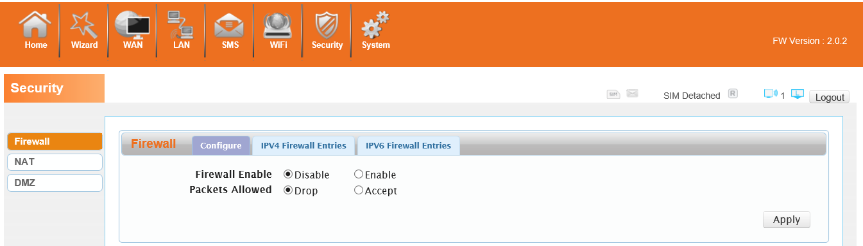

### 3.8.2 NAT

The 4G680V2.0 supports NAT/IPSEC VPN Pass Through/PPTP VPN Pass Through/L2TP VPN Pass Through/Webserver WWAN Access.

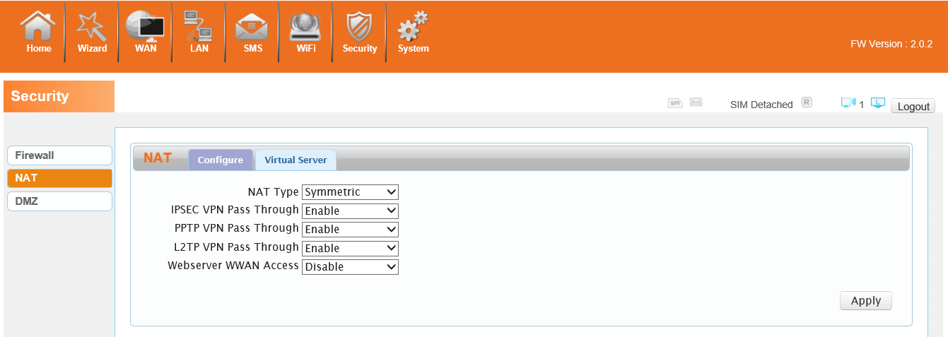

When some hosts inside the private network have already allocated the local IP address, that is, only the private address used in the private network, but now they want to communicate with the host on the Internet (no need to encrypt), we can use the NAT method.

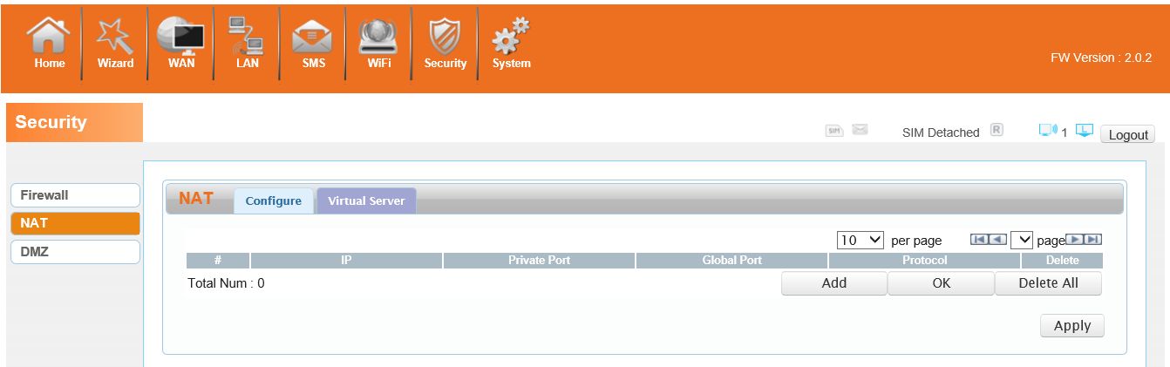

### 3.8.3 DMZ

Receive all the data from external network interface forwarded to “DMZ IP address”

**Enable DMZ**: If an application has trouble working from behind the router, you can expose one computer to the Internet and run the application on that computer.

Note: Placing a computer in the DMZ may expose that computer to a variety of security risks. Use of this option is only recommended as a last resort.

**DMZ Address**: Specify the IP address of the computer on the LAN that you want to have unrestricted Internet communication.

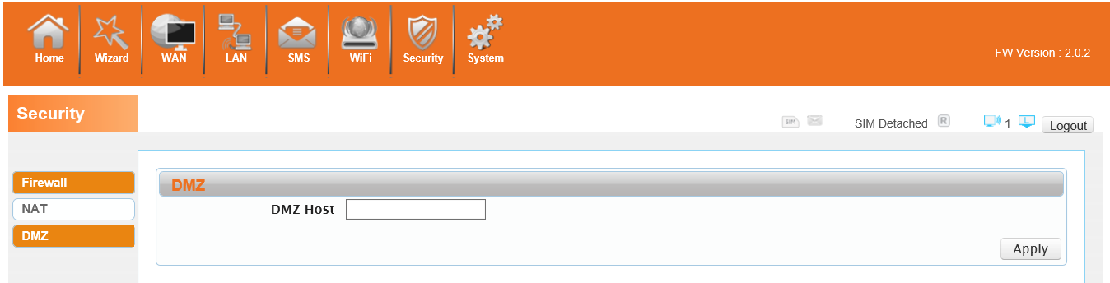

## 3.9 System

### 3.9.1 About

4G680V2.0 displays some basic information, such as Device Name, Firmware version, IMEI, MEID, Baseband version.

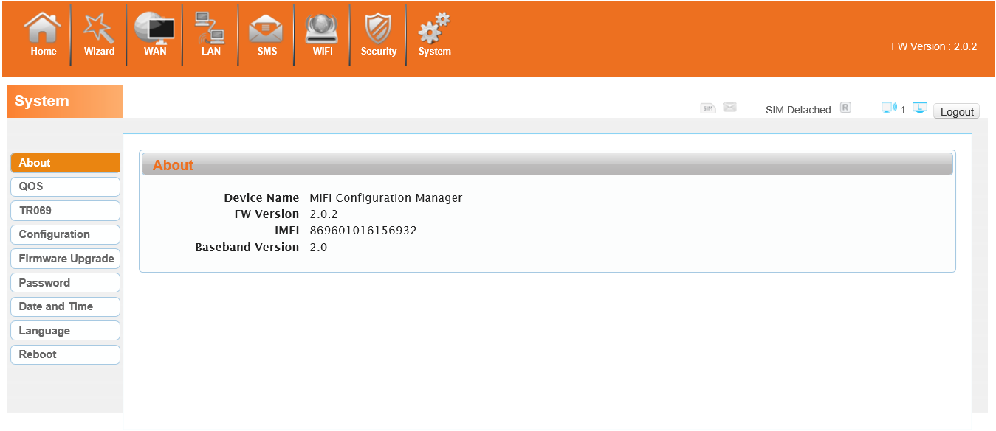

### 3.9.2 Qos

Quality of Service, by setting up some rules, to provide better service to the user specified, make some data request priority; Or restrict the network quality of some users, so that they don't affect other users

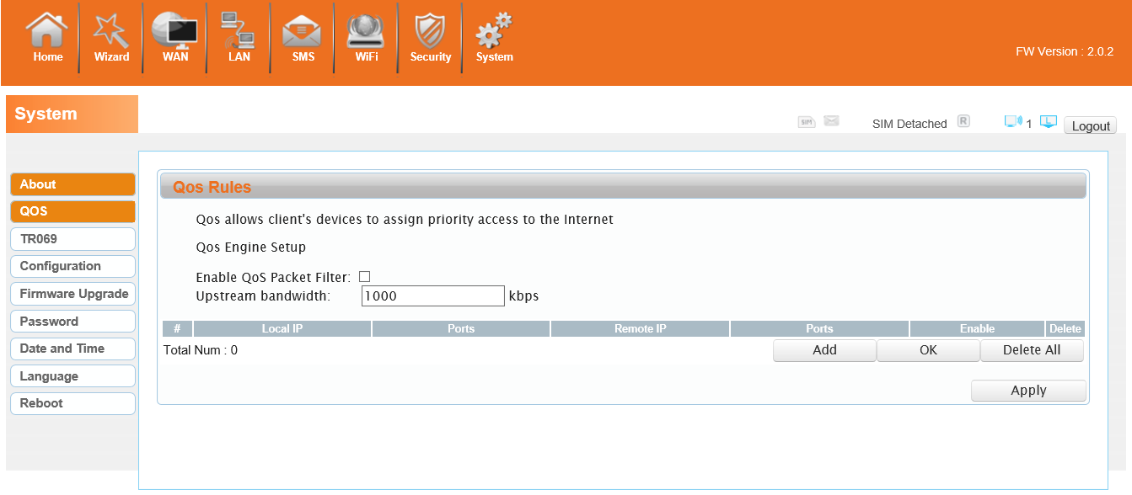

### 3.9.3 Configuration

Restore the factory settings, all of the personal configuration will be deleted, all configuration pages will be restored to the factory defaults.

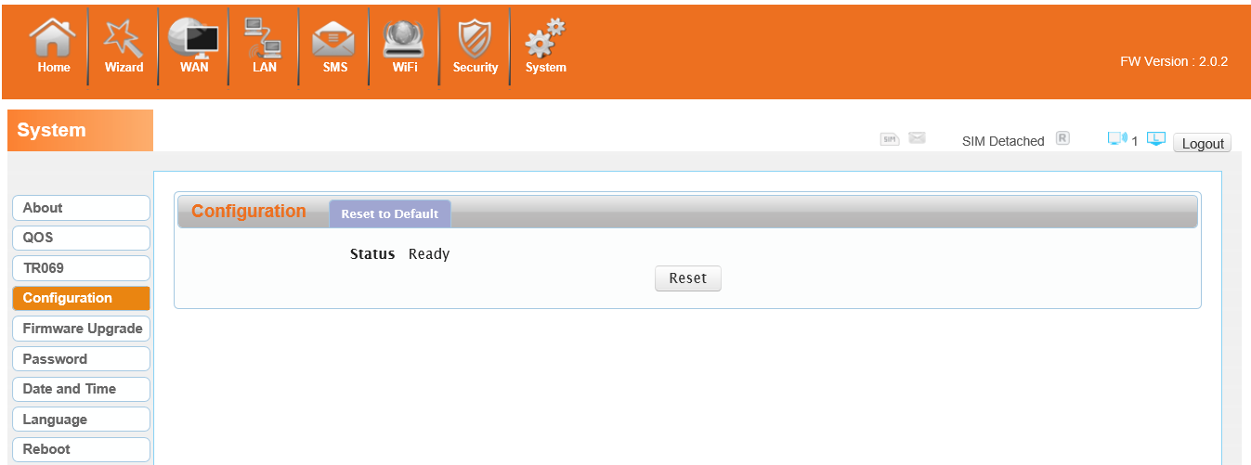

### 3.9.4 Firmware Upgrade

The page allows you to upgrade the router’s firmware. You can on the routing connection network conditions, check whether there is a new version, if there is a new version was detected,  can be directly upgrade; Or from the official website to download updates to the local computer, and then choose to download in the page of upgrade file to upgrade.

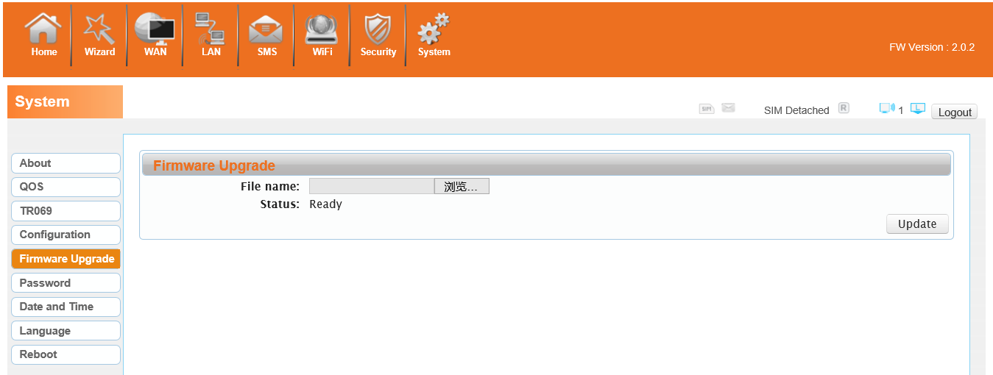

### 3.9.5 Password

Modify the login password for administrator interface. Also you can set the time to logout the UI automatically.

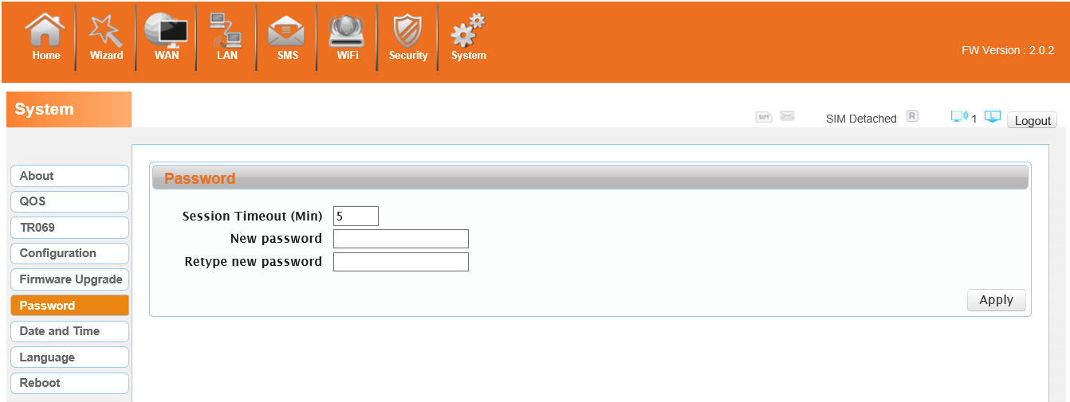

### 3.9.6 Date and Time

You can synchronize the local time, you can also select the time zone

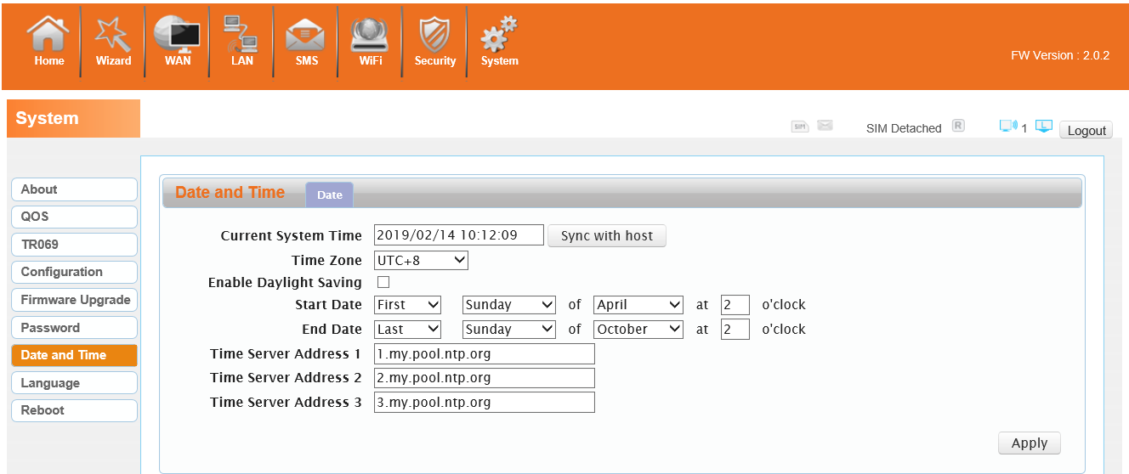

### 3.9.7 Language

You can change the UI language in this page.

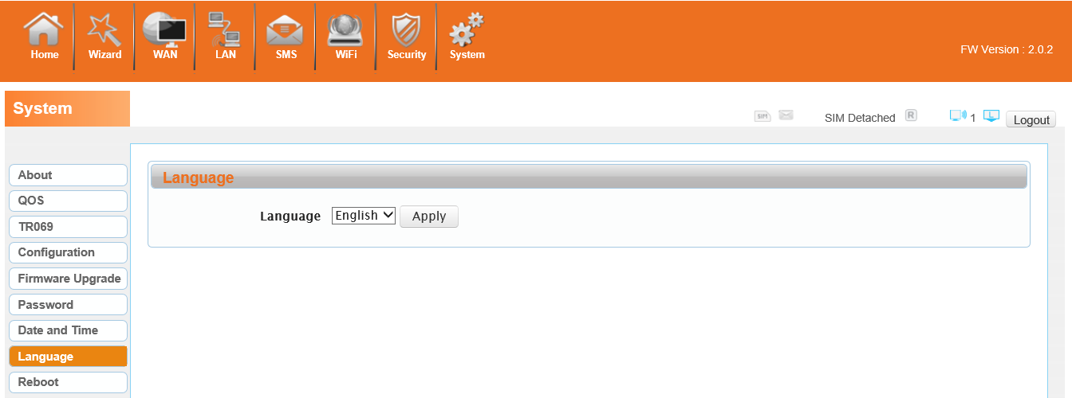

### 3.9.8 Reboot

Reboot the 4G680V2.0.

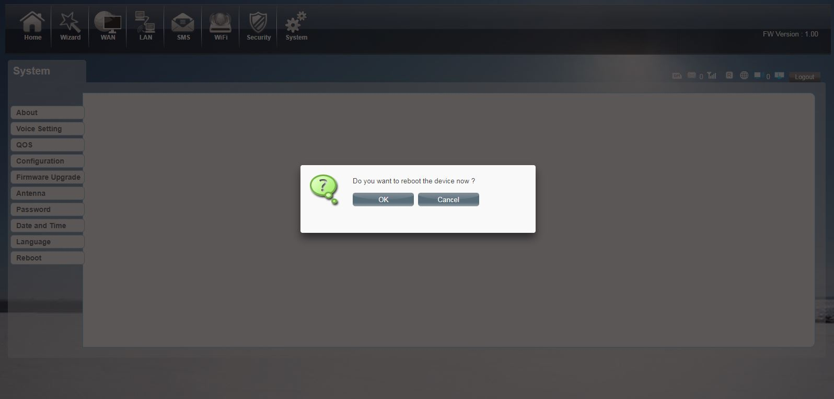

# Appendix Ⅰ:

Call function:

This device provides call and text message functions. When you browse internet, you can keep connection with your family and friends.

The steps are as follows:

1. Insert 3/4G SIM card, and open the device
2. Connect the telephone through the RJ11 port of the device
3. When phone function is booted up, your telephone's signal LED will turn on. Then you can start to use the call functions.

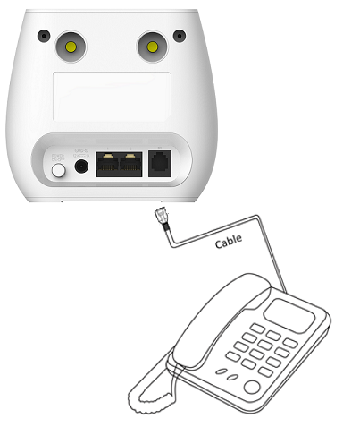

Caution:

1.      Please make sure that your SIM card supports voice call service

2.      Please start to use the call functions; after call function is fully booted up (all text messages are received)

# Appendix II

# FAQ:

This Appendix provides solutions to some problems that could be seen when install and use the device. Please read the following instruction, it will help you to solve these problems. If you fail to solve your issues from this FAQ, please contact us.

|  |  |
| --- | --- |
| **Problem** | **Solution** |
| Wireless device cannot connect to SSID. | * + Please make sure the wireless function of your PC is turned on. If it is already on, please refresh the network list.   + Please make sure your PC is in the wireless signal coverage of the device.   + Please make sure your device is away from the electromagnetic interference.   + Please make sure your device’s wireless function is turned on.   If the problem is still not solved, please try to reset your device to default settings. |
| Cannot Access internet: | * + Please make sure your PC is in the wireless signal coverage of the device.   + Please make your device’s DHCP function is turned on.   + Please make sure your firewall is turned off.   If the problem is still not solved, and your PC has got connected to the network, but the wireless icon shows an yellow exclamation mark. It means your wireless card could not be allocated an IP address. Please use the static IP settings, and fill DNS and gateway according to instructions of your operator. |
| Input IP, but fail to login to the administration page. | * Please make sure the problem is not caused by the Cache of the internet browser, please clean up the Cache. * Please make sure the network connection is good, and the light of connected ports are on. * Please make sure the username and password are correct   If the problem is still not solved, and your PC already gets the IP address. You can try to use wireless connection or static IP methods to try it again.  If connected via wireless connection, please try to ping 192.168.0.1 to see if there is any response. If responses are received, please check if you set an agent server for connection. If no agent server is set, then please not to set an agent server, and reset the device. |
| IP conflict ion when turn on the device: | * Please make sure if your LAN has other DHCP servers. * Please make sure that IP address is not occupied by other computers or devices. If occupied, please change the IP address of that device to avoid the IP conflicts. |

# Appendix III:

**Safety warning:**

**Read the user guide:**

Please read the user guide before using this device.

**Stay away from interference:**

All the wireless devices could be possibly interfered, and it will affect the performance of the device

**Turn off the device in restricted area:**

Please follow any instruction, turn off the device around airplanes, medical devices, gases, chemicals or explosive areas

**Qualified services:**

Please don’t disassemble this device yourself. Please contact professionals to repair and install the device.

**Accessories:**

Please don’t touch the device using wet hands, when it is in charge. Please only use the accessories and that are recognized to be compatible to the device.

**Danger of explosion:**

 Turn off your device in any areas that explosion could possibly happen. Please follow all the notices in the areas where spark could cause fire or explosion.